LECTURE #2 (Course – Psychology of Communication, Lutsenko, O. L., 2018)
Topic: Critical thinking
Topic 3-4. Principles of critical thinking
Basic definitions. A comparison of critical and ordinary thinking. Recommendations for critical reading and evaluation of information. Recommendations for effective writing of reports. The main elements of critical thinking. Techniques of verbal and written persuasion. Logical errors. Comparison of critical thinking and general intelligence.

Critical thinking
Do you think that critical thinking is equal to general academic abilities? If so – you are wrong. It is different complex ability.
IQ  - verbal memory;  - figural memory;  - logical thinking;  - figural-visual knowledge;  - numerical knowledge;  - general knowledge;  - attention level etc. | Critical thinking  - Understanding and use of oratory;  - Prediction and prevention of problems;  - Knowledge of "logical fallacies“;  - Critical reading and writing style;  - Recognition of statistics manipulating;  - Recognition of manipulating in advertising and propaganda;  - Techniques of dishonest dispute etc.

Why thinking critically is so important? Because very often we tend to guessing instead of estimating, preferring instead of evaluating, grouping instead of classifying, supposing instead of hypothesizing, believing instead of assuming etc.
Schneider describes human minds as belief machines. W. James also said: “As a rule we believe as much as we can. We would believe everything if only we could” (quoted from Hogan, 2009). Yes, it can be useful to have some positive illusions for maintain optimism and self-esteem, but sometimes it lead to severe disappointments and our imperfect thinking can be used against us by others.

Definition: By B. Black (Black, 2012) Critical Thinking is the analytical thinking which underlies all rational discourse and enquiry. It is characterized by meticulous and rigorous approach. As an academic discipline, it is unique in that it explicitly focuses on the processes involved in being rational. These processes include:
• analyzing arguments,
• judging the relevance and signiﬁcance of information,
• evaluating claims, inferences, arguments and explanations,
• constructing clear and coherent arguments,
• forming well-reasoned judgements and decisions.
Being rational also requires an open-minded yet critical approach to one’s own thinking as well as that of others.

Comparison features of the ordinary and critical thinking (M. Lipman, 1988)
Critical Thinking | Ordinary Thinking
Estimating | Guessing
Evaluating | Preferring
Classifying | Grouping
Assuming | Believing
Inferring logically | Inferring
Grasping principles | Associating concepts
Hypothesizing | Supposing
Noting relationships among other relationships | Noting relationships
Making judgments with criteria | Making judgments without criteria

The main elements of critical thinking
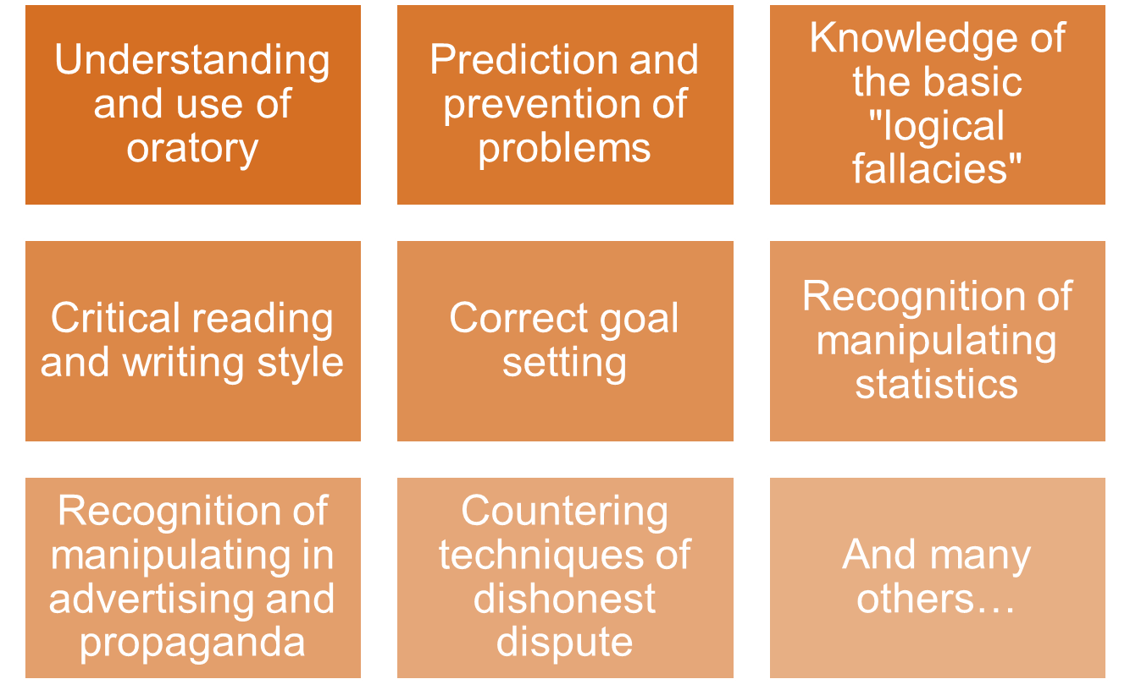

Recommendations for critical reading and evaluating information
Use the criteria: Who? Why? What? When?
Who? Look at the qualification of the authors and sources of experience. Whether they are experts in their field? Whether they are published anywhere else? Are they sponsoring by someone or not? Were they cited by other specialists in their field? Is the publisher recognized and authoritative organization? Do they provide contact information?
Why? Look at the purpose of the information. Whether the information is intended to inform, persuade, or entertain? Is there sufficient evidence that there have been no complaints? Were the studies sponsored? Is this objective or biased? Who is the target audience? Is it use emotional language?
What? Look at the relevance of the information. Does it provide information at the appropriate level for your needs? Is this true in terms of geographic location? Is this an original or a secondary material? What this material is focused on? How limited is the coverage?
When? Look at the novelty of information. Is there a publication date? When was it last updated? Are the links still active (the site)?

Recommendations for effective report writing
To write well-structured report it need to involve such writing abilities:
- Ability to draft an outline plan.
- Ability to formulate the head of report.
- Skills to write abstract if the report is long.
- Ability to set up the goal and the tasks of your report.
- Skills to structure materials and to design the detailed plan of your report.
- Ability to formulate conclusions, to add necessary appendix.
Academic style of writing
The following characteristics are typical of academic writing:
- Use of correct grammar and punctuation;
- Use cautious (probabilistic) language;
- Avoid subjective and emotive language;
- Use linking words and phrases;
- Use correct referencing;
- Clear and concise language;
- Formal writing style.

Techniques of verbal and written persuasion
These techniques show the reader that the point of view of the author should act as their own point of view.
1. Rhetorical question: means that the answer is so obvious that other answer is not required.
Example: Can we expect that our teachers will maintain a high level of professionalism, if we do not pay them a fair wage?
2. The Rule of ‘Three’: based on the observation that people better remember things when they are listed in three. The same idea can be told in 3 different ways.
Example: "Stop, look, and listen"; “Is your car old? rusting? ready to be replaced?”
3. Emotional language: it is using adjectives (nouns, verbs), so that the reader could feel a certain emotion.
Example: Management will not stop these cuts, and all of our children will go hungry. Then they close the plant and leave us without work and on the street.
4. Hyperbole: The use of exaggeration for extravagant effect; often used humor.
Examples: "A hundred years have not seen," "I've said it a thousand times."
5. Sound model: designed to attract the reader's attention and remember the contents better:
- Rhyme, - alliteration (repeated one the same sound at the beginning of words), the repetition of the same consonant sound, repetition of vowel sounds.
Examples: sweet smell of success; dime a dozen…
6. Comparisons: show a relationship between two unlike items in one of three ways:
metaphor
Examples of metaphor: ‘‘golden hair’’, ‘’sunny smile’’.
simile (uses “like” or “as”)
Examples of simile: the foreman is tough as nails.
personification (uses an animal compared to a non-animal)
Examples of personification: she eats like a pig;
he’s an ostrich — he won’t face his problems.

Activity 1. Recognize rhetorical techniques
1. ‘’In conclusion, let me say that voting for this candidate - is a vote for a perfect world’’.
2. She is smart, sincere and successful.
3. She knows how to get things done. Other candidates want to take us back to a time when jobs are scarce, people were scared and the government intervened in the lives of people. Let's not let that happen.
4. Why turn the clock back, if we can move forward to a brighter future?
Sound model _____
Hyperbole _____
Rhetorical question _____
“The Rule of Three” ______
Emotional language ______

Logical Fallacies
«Slippery slope». The argument might have two true premises, and a conclusion that takes them to an extreme.
Example: “We have to stop the tuition increase! Today, it’s $5,000; tomorrow, they will be charging $40,000 a semester!”
False dilemma - which presents in its major premise just two options (“either-or”) when in reality there are others.
Example: “Stop wasting my time in this store! Either decide you can afford the stereo, or go without music in your room!”
Circular reasoning - there is just one premise, and the conclusion simply restates it in a slightly different form.
Example: “I told you to clean your room!” “Why?” “Because I said so!”
Equivocation - uses a word twice, each time implying a different meaning of that word, or uses one word that could mean at least two different things.
Example: “Hot dogs are better than nothing. Nothing is better than steak. Therefore, hot dogs are better than steak.“
“Red herrings” – are simply any unrelated topic that is brought into an argument to divert attention from the subject at hand.
Example: “Nuclear power is a necessity, even though it has the potential to be dangerous. You know what is really dangerous, though? Bathtubs. More people die in accidents in their bathtubs every year than you can imagine.”
Post Hoc (after this, therefore because of this) – occurs when an assumption is made, because one event precedes another.
Example: A tenant moves into an apartment and the building's furnace goes faulty. The manager blames the tenant's arrival for the malfunction.
Hasty generalization – when premises do not contain enough evidence to draw a conclusion.
Example: That new police drama is a really well done show. All police dramas are great shows.
“Chicken and egg” fallacy - an error by confusing cause and effect.
Example: Last night I had a fever. This morning, I have a cold and a fever. The fever caused the cold.
Composition fallacy – by focusing on parts of a whole and drawing a conclusion based only on those parts. Example: Every player on their team is excellent. So their team must be excellent, too.
Unfinished claim – when advertising claims the product is better, or has more of something, but does not finish the comparison.
Examples: "Magnavox gives you more." More what?
"Anacin: Twice as much of the pain reliever doctors recommend most."
Does not say twice as much of what pain reliever.
Statistics manipulation
Statistics was invented to get evidences, to bring valid information, to make possible more rational decisions and inferences but now it is often used for opposite purpose – for manipulations.
Example of statistics manipulation
- company claims it is edging out its competitor with higher sales. They are stated that they have had a 50% increase in sales, compared with only a 25% increase for their competitors.
Is their claim valid?
- What if the competitor sold 2000 bicycles last year, and 2400 this year;
the other company sold 40 bicycles last year, and 60 this year.
Won they the competition? How second company has manipulated by statistics? They leaved out key information.

Prevention of statistics manipulation
When you come across statistics in advertising, in a report, a political speech, a press, or other source, remember that this is not necessarily true.
Ask yourself three questions:
Is this statistic reliable?
Is there no deliberate misrepresentation here?
Do they provide you with all the information you need to evaluate?

The distinction between facts and opinions
Mark each statement as (F) of fact or (O) opinion.
___ 1. World War II began on September 1, 1939.
___ 2. Cream Brylle is the most delicious dessert.
___ 3. I went to rest in the Carpathians in the past year.
___ 4. To invest in the stock market is a bad idea.
____ 5. My presentation was great. Now the administration will pay attention to me.
____ 6. My presentation was great. This was noted in my attestation.

What is your conclusion – how can we find the difference?

In conclusion…
"Read not to contradict and confute; nor to believe and take for granted; nor to find talk and discourse; but to weigh and consider."—Francis Bacon

