УДК 378.147.1:004.77
©. Arkhipova T, Bailo M.

EDUCATIONAL AND SCIENTIFIC PORTALS IN ORGANIZATION OF EDUCATIONAL PROCESS AT HIGHER EDUCATION ESTABLISHMENTS

Content and quality of education it is correspondence to modern requirements of the society the priority direction of the development of Ukrainian society in conditions of European integration. Openness and accessibility of education determine the state of the intellectual potential of the state. Important resource of quality and accessibility of professional-technical education increase is efficient implementation of information-communication technologies (ICT). This concerns not only educational-production process but also management of education, system of teachers staff qualification increase, etc.
That is why, it should he underlined at that outstripping development of professional education sphere, based on integration of pedagogical, information and telecommunication
technologies, creation on their basis educational portals of higher education establishments,
districts regions with corresponding scientific-methodological content and possibilities of application of scientific, educational and managerial rezones in the process of solution of
multilevel tasks becomes important national priority. Symbols of education used to be knowledge,
skills, civil education, whereas new approach to education assumes competence, erudition, individual creativity, independent search of knowledge and need in their perfection. Formation of internal demand for self-education becomes the requirement of the present time and condition for realization of personal potential. The ability of the person to realize oneself professionally at rather high level, depends on the possibility to master new professional knowledge.
The solution of these problems is impossible without strict planning of all stages of educational process with deep interdisciplinary coordinator of the subjects of professional orientation of education establishment, that can be provided by means of information- communication technologies for creation of the portals of chairs, institutions, departments.
PROBLEM SET-UP. Application of ICT in educational process of higher education. Establishment allows to realize the ideal of individualization and differentiation of educational
process in higher education establishment [6], provide higher level of knowledge, skills of students
as a result of positive impact of ICT [1, 4, 6]. Besides, introduction of distance education (DE) becomes possible in Ukraine, creation of the system of life-long education will accompany all active professional life of people. Unified system of education will be replaced by variative by the content, methods and forms, duration and methods of teaching system of multilevel educational establishments, united by ICT facilities – electronic information – educational portals.
ANALYSIS OF THE RECENT RESEARCH. Theoretical-methodological and methodic fundamentals of the development of information-communication technologies, problems of design, creation and application of ICT on the example of educational methodical complexes are presented in the research, performed by V.Bykov, R.Hurevytch, Yu.Zhuk, O.Shestopaliuk and Otsu’s. Peculiarities of ICT application for training of teachers are considered in scientific, educational methodical works of ofM.Kademija. Problems, connected with the formation of professional knowledge of pupils of professional educational establishment by means of multimedia are considered in dissertation research of L.Shevchenko, J.Kedrovytch, L.Konoshevskiy, V.Kykharenko. Proweding from the above-mentioned, the aim of the given research is substantiation of theoretical fundamentals of ICT (educational portals) application for the organization of educational process a higher education establishment, namely, DE.
PRESENTATION OF MAIN MATERIAL. To provide the efficiency of DE, technology that integrates traditional forms of education – ICT and allows to realize educational process at the
distance from basic educational establishment, great attention is paid to proper usage of the latest
achievements in the sphere of ICT, namely: computer networks, software facilities
(telecommunication, information, organizational, methodical). In other words, using ICT facilities we must provide the audience with: educational-methodic materials, means of communication and

control of knowledge. By their content all these components must correspond to the requirements of state standards of education, which stipulate constant renewal of content element.
The necessity to implement ICT in educational activity of higher education establishment as well as taking into account peculiarities of DE organization regarding the training of future
professionals, in our case, teachers and engineers-welders we carry on the research concerning the creation of multilevel, multi-functional information education portals of the Departments of Innovative and Information Technologies in Education (IITE) of the Graduate, Postgraduate and
Doctoral Institute of Vinnitsia State Pedagogical University and Institutes of Wear resistance increase technology of the Department of automobiles and their Repair and Restoration, which
Realize their Repair and Restoration, which Realize their concept of accessible high quality education. DE is the successor of extra-mural form of teaching. Creation of information- educational portal of higher education establishment eliminates the contradictions between full-
time and extra mural forms of education that represented qualitative and mass approach to education.
Serial implementation in educational process on-line education promotes allocation of actual educational information on the portals of higher educational establishment and creates conditions for integration in educational process the educational content, innovation educational technologies,
organizational models of education, improvement of professional competence of the teachers [3].
At the above-mentioned chairs of Vinnitsia State Pedagogical University and Vinnitsa
National Technical University educational-scientific portals are created.
Due to the resources of the portals users get the possibility to obtain information regarding the activity of the Chairs in various fields: education activity (state attestation of educational-
qualification levels; diploma and course papers, performed by the students; practical classis in
information technologies, working profession training, preparation for the exams; scientific activity (directions and materials of scientific-research work; subject of scientific research; training
of scientific and pedagogical staff; experimental work; Intel project “Education for the future”;
scientific pedagogical practice of masters; publications of the Chair);
activity of the chair subjects and materials of reports at methodical seminars; all-Ukrainian and International Contests; cooperation with Ukrainian educational establishments; cooperation
with foreign educational establishments; open classes, conducted by the teachers of the Chair);
information, regarding the Chair (addresses, phone numbers of the teachers of the Chair;
researchers; planning the work of the Chair, photo gallery of the Chair); pages of trade union committee of the Chair, plans and materials. Portal of the Chair of wear resistance increase of VNTY has different structure; mane page contains information regarding specialties and specialization; short historic reference of the Chair; structure of the Chair (administration of the, teacher’s staff, Post graduate students, masters, material-technical base of the Chair); information, regarding scientific-research work of the Chair (research work, supported by state budget and self- supporting economic activity, participation in the conferences, list of publication post graduates activity); information concerning disciplines, taught by the Chair, manuals and methodic guides, information, regarding scientific-methodic work and information packages of disciplines, news of the Chair (for instance, information about scientific-practical conference of the Chair or Department), entrance information, Fig. 1.

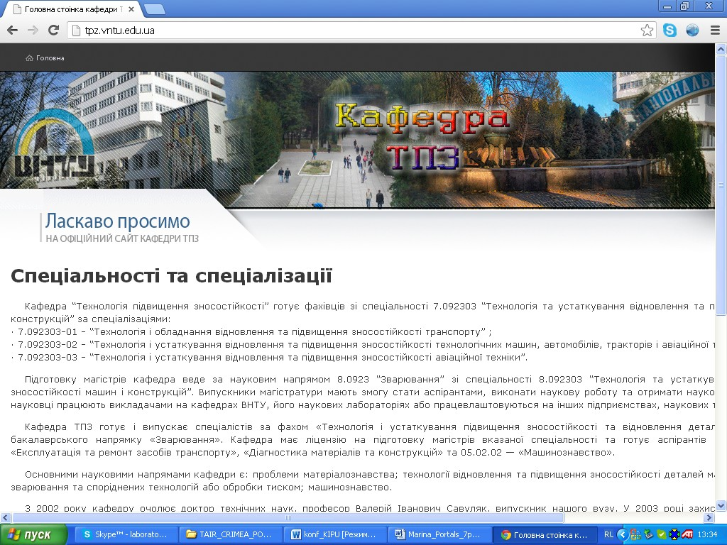
Fig. 1. Page with entrance information

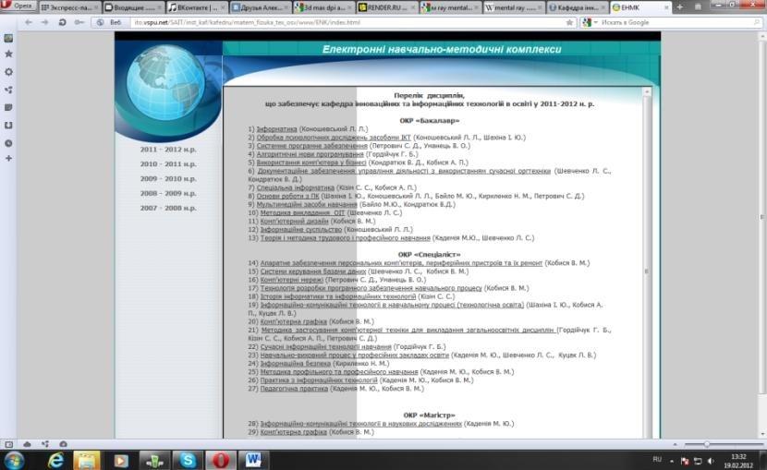We will consider in details the Section “Electronic education-methodical complexes” (EEMC) of the Chair IITE, that consists of the parts, which correspond to educational- qualification level “Bachelor” and “Specialist”, Fig. 2.

Fig. 2. Main page of the Section “Electronic educational-methodic complexes”

From this page we can pass to any EEMC from any discipline, provided by the Chair, according to the directions of future teachers training, for instance, to the discipline “Multimedia means of education” (Fig. 3).
EEMC on the discipline “Multimedia means of education” contains such Sections: methodic
materials (abstract, education programme, working programme, thematic plan); education material (lectures, lab works, electronic manual, literature, glossary), knowledge control (criteria of evaluation, control questions, tests, complex test work); individual work, students papers.

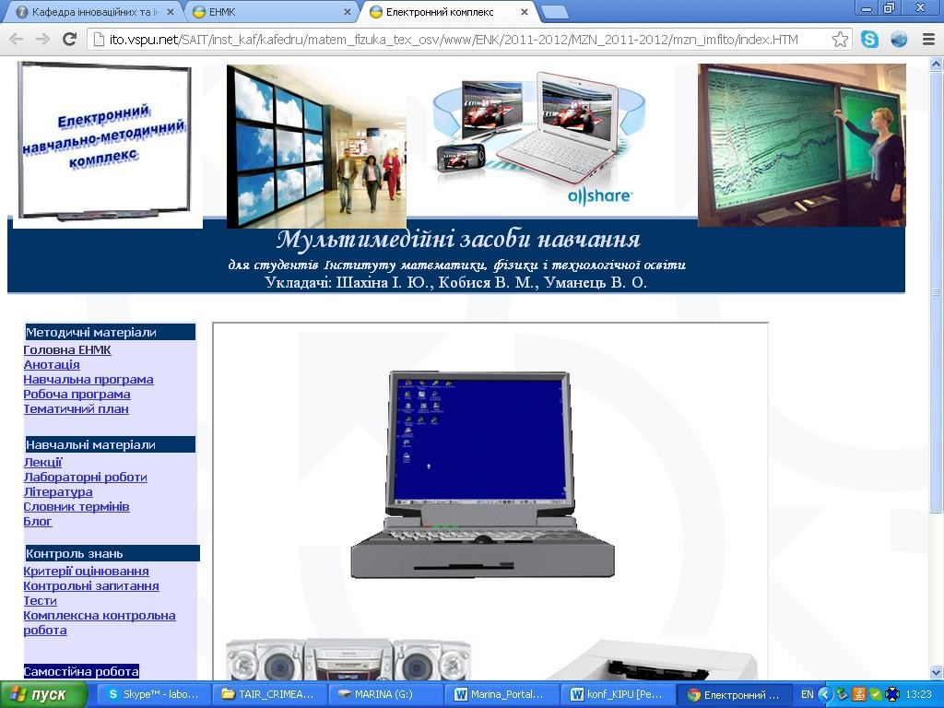
Fig. 3. Main page of EEMC “Multimedia means of education”

This discipline is studied by the students of all the directions of training. Students of natural sciences study this discipline according to the curriculum that differs from the curriculum for humanities students. That is, to complexes of the discipline “Multimedia means of education” are located on the portal of the Chair for natural sciences students and humanities students. Working programs are elaborated for various directions and specializations and have professional orientation. EEMC from the discipline “Multimedia means of education” allow to realize following tasks: 1) provide wide and qualytive access to available pedagogical programming facilities (PPF), to infrastructure resources of the chair; 2) creation of technical possibilities for the search and study of the material, proposed in accessible form of information to thematical blocks, that helps the students to obtain needed information in full volume; 3) stimulation of the process of innovation PPF creation; 4) education-methodical of support of educational process.
We will consider the work of the students with EEMC “Multimedia means of education”.
Having obtained the access to education-methodic materials in electronic form, the student prints out the material or study it directly from the screen. Besides in the process of study, the student can individually and autonomously address to different section of the discipline, this will help the student to widen and deepen knowledge regarding the usage of multimedia means of education in future professional activity after studying certain volume of the material, the student may written form (by E-mail or Skype) put questions to the teachers and get answers from them. Further, as the continuation of education process, to check the quality of mastering the teacher may ask several control questions sending them to the student by E-mail. Student can perform self-testing, using electronic tests, located at EEMC, to prepare for the defence of laboratory works, passing the exams. Test (exam) student passing personally during the direct contact with the teacher in a traditional form: test cards – question – practical task – answer (test). The same structure has structure EEMC of the discipline “Technology of Metals and Material Science”.
CONCLUSIONS. Application of information – communication technologies (ICT) in educational process considerably increases the level of knowledge and skills of students, improves
the level of material mastering, increases the level of cognitive interests of students and motivation
component of educational activity, stipulated by the fact that application of innovation technologies is new phenomenon.

Scientific-educational portals, created by means of ICT, gives the possibility to update dynamically educational-methodical resources, suggested the students PPF, created by the teacher, apply pedagogical technologies, that take into account cognitive abilities of the students.
Introduction of educational-scientific portals provides for the teacher additional possibilities to solve successfully complex scientific-methodical tasks: establishment of content connection in
the chain “general – particular - singular”, selection of didactically substantiated techniques of
mastering new knowledge, usage of variational and combined techniques (technologies) of educational taking into account real readiness of the students to reproductive and productive type
of educational activity; provide widening of subjective status of the student in his educational
activity, as it allows the student to find his optimal educational trajectory (time, rate, volume of studied material, sequence of mastering, etc.).

References

1. Башинська Т. Проектувальна діяльність основа вчителя і учнів / Т. Башинська //
Початкова школа. – 2003. – № 7. – С. 35–38.
2. Гуревич Р. С. Організація баз даних у MS Access : навч. посіб. для учнів і студ. нетехн.
навч. закл. / Р. С. Гуревич, Л. В. Жиліна, М. Ю. Кадемія. – Вінниця : ДОВ «Вінниця»,
2006. – 252 с.
3. Калюжна Т. М. Організаційно-педагогічні умови застосування освітньо-наукового порталу в системі екстернатної підготовки фахівців у технічному університеті : дис. … канд. пед. наук : спец. 13.00.04 «Теорія і методика професійної освіти» / Т. М. Калюжна. – К., 2009. – 183 с.
4. Крилов І. В. Інформаційні технології: теорія і практика / І. В. Крилов. – М. : Центр,
1996. – 156 с.
5. Кухаренко В. М. Дистанційне навчання : Умови застосування. Дистанційний курс :
навч. посіб. / В. М. Кухаренко, О. В. Рибалко, Н. Г. Сиротенко ; за ред. В. М. Кухаренка.
– 3-є вид. – Х. : НТУ ХПІ, Торсінг, 2001. – 320 с.
6. Ларионов В. В. Видовое информационное поле в инновационной педагогике: состав, структура, свойства и применение в тестировании / В. В. Ларионов // Инновации в
образовании. – 2005. – № 1. – С. 55–62.

T. Archipova, M. Bailo
Educational and scientific portals in organization of educational process at higher education
establishments
This article proposes conceptual approach of information and communication technologies using in educational process in universities of Ukraine in terms of education and research portal. It
is shown methodology of the use of portal of department of innovative and informative
technologies in formation of the Vinnytsya state pedagogical university at the study of discipline
«Multimedia facilities of educating» and portal of department of technologies of increase of
wearproofness of the Vinnytsya national technical university at the study of discipline
«Technology of metals and in the course. The paper considered Material Science for organization of education of students to the profession work.
Keywords: information and communication technologies, educational and research portal,
distance education, multimedia learning.

Архіпова Т. Ф., Байло М. Ю.
Освітні і наукові портали в організації освітнього процесу в установах вищої освіти
Запропоновано концептуальний підхід до застосування інформаційно-комунікаційних технологій з метою організації навчально-виховного процесу в ВНЗ України в умовах використання освітньо-наукового порталу. Відображено методику використання порталу кафедр інноваційних та інформаційних технологій в освіті Вінницького державного педагогічного університету при вивченні дисципліни «Мультимедійні засоби навчання» та

порталу кафедри технології підвищення зносостійкості Вінницького національного технічного університету, для організації навчання студентів робітничим професіям.
Ключові слова: інформаційно-комунікаційні технології, освітньо-науковий портал, дистанційна освіта, мультимедійні засоби навчання.

Архипова Т. Ф., Байло М. Ю.
Образовательные и научные порталы в организации образовательного процесса в
учреждениях высшего образования
Предложен концептуальный подход использования информационно-
коммуникационных технологий для организации учебно-воспитательного процесса в ВУЗах Украины с использованием образовательно-научного портала. Рассмотрена методика использования портала кафедры инновационных и информационных технологий в образовании Винницкого государственного педагогического университета при изучении дисциплины «Мультимедийные средства обучения» и портала кафедры технологий повышения износостойкости Винницкого национального технического университета для организации обучения студентов рабочим профессиям.
Ключевые слова: информационно-коммуникационные технологии, образовательно-
научный портал, дистанционное образование, мультимедийные средства обучения.

Стаття надійшла до редакції 10.06.2013 р.

